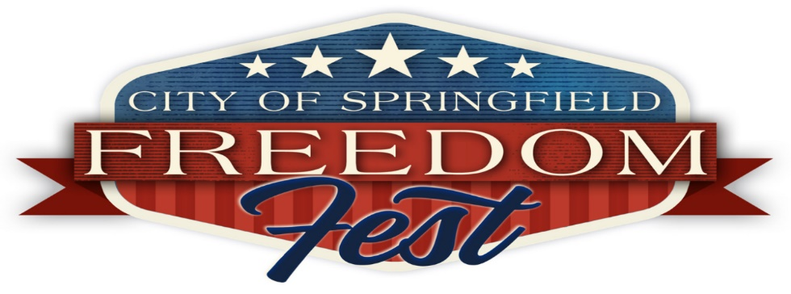

CONCERT LINE-UP

3:15 PM- JUSTIN TUCKER BAND
4 PM- DEVIN WILLIAMS
4:45 PM- THEO AND BRENNA
5:45 PM- STEPHAN HOGAN
6:30 PM- EMILY ANN ROBERTS
7:20 PM- RICKY SKAGGS

